Database Migration with ORM stack

Contents

1. Introduction 3
2. Workflow diagram to deploy the stack 3
3. Create stack for Database Migration 4
4. Plan the Job 7

Introduction

OCI Database Migration (DMS) migrates Oracle databases from on-premises or cloud deployments to OCI. The easy-to-use graphical user experience validates and manages migration workflows. DMS transparently uses Oracle Zero Downtime Migration (ZDM), Cloud Premigration Advisor Tool (CPAT), Oracle Data Pump, and Oracle GoldenGate services for secure, fault-tolerant, and incremental migrations.

Workflow diagram to deploy the stack

Below diagram shows how the Terraform Artifact are applied in the OCI. While creating a ORM stack, using terraform deliverables Init, Plan and Apply is the flow to provision the resource in the OCI. We can have the deliverables in any of below.

- GitLab/GitHub Repo
- Bitbucket
- Can be in folder/.zip in the local disk
- Object Storage Bucket
- Can be in compartment
- Oracle provided Template

Prerequisite
- Create a Vault
- Create Databases
- Create an Object Storage Bucket
- Create Registered Databases

Create stack for Database Migration

Go to OCI Console Developer Services Resource Manager Stacks select the compartment Create Stack

My Configuration Folder Browse Select the “Database Migration” folder that contains the terraform Upload

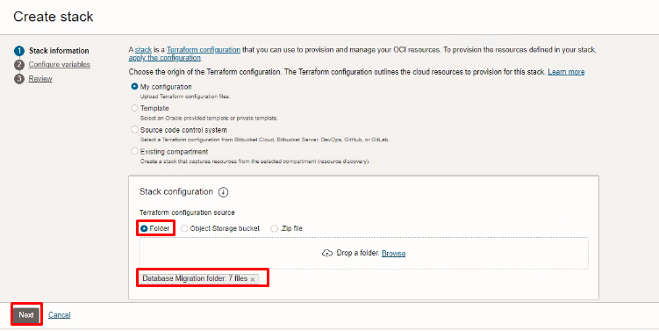

Select the parameters as per the below screen,
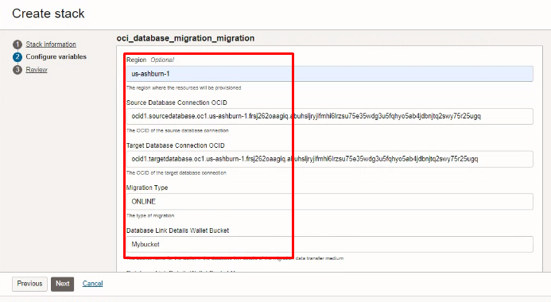
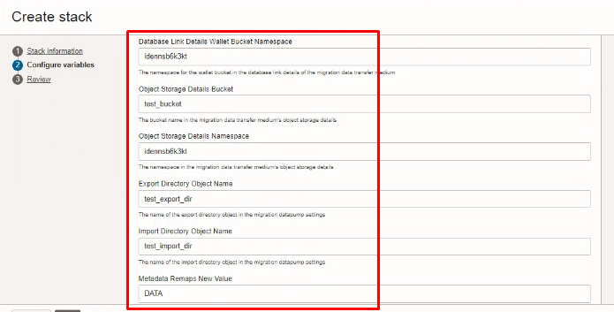
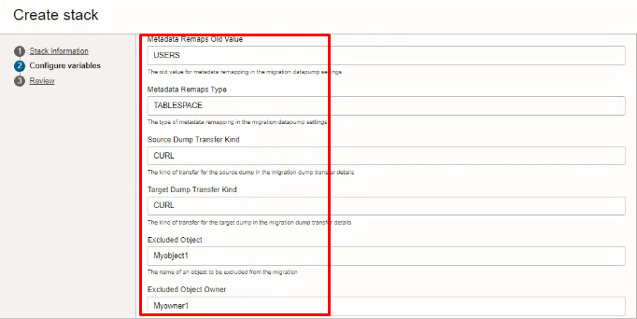
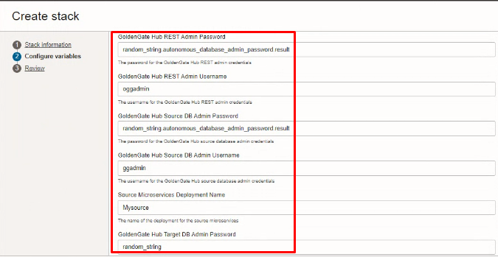
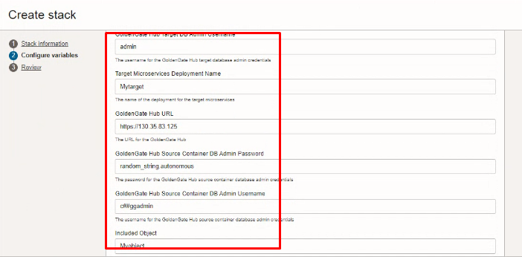
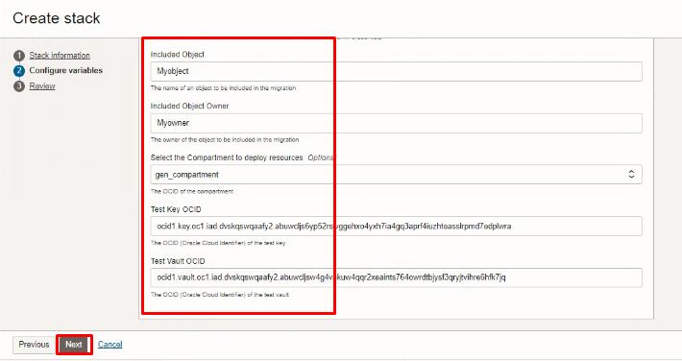
Click “NEXT”
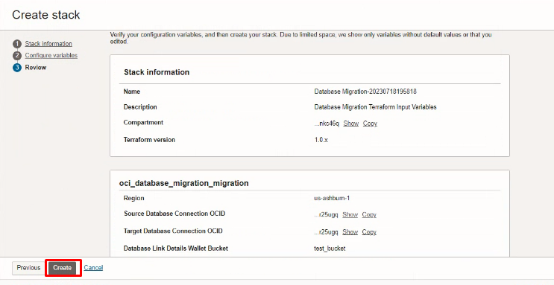

Click “CREATE”

Plan the Job

Click the “Plan”
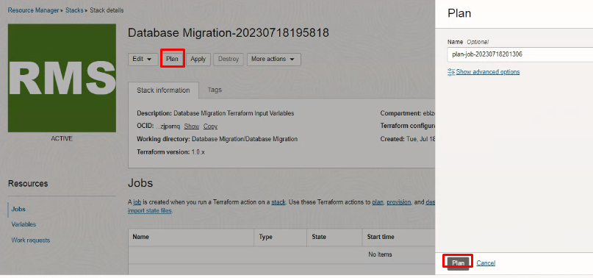

Verify the Plan is successful.

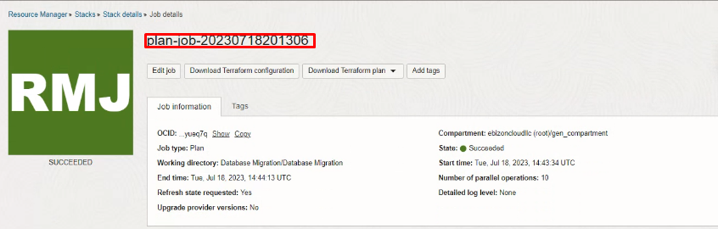
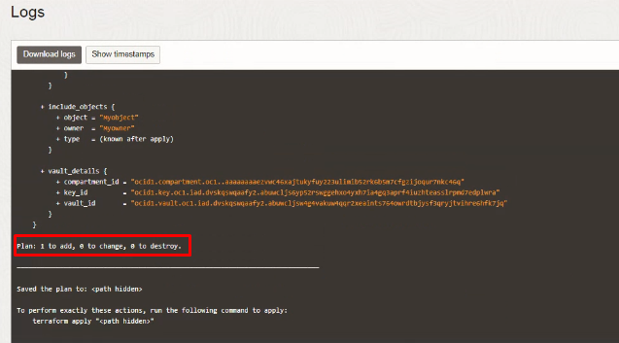

#END#

